Outside Air Temperature Function – F5x Specific - CGEA1.3

Functional Description

The Outside Air Temperature (OAT) display allows the driver to see the outside air temperature in the cluster.

This STSS is specific to MY20 F53, and is not expected to be used on any other vehicle. (Except for possibly future F5x, but hopefully not).

The supplier will use an internal configuration based on F5x part numbers, and then follow this STSS for F5x part numbers, and follow the standard Outside Air Temp Function - CGEA1.3 STSS for NON-F5x parts.

The system issue that caused this situation is summarized below.

In 2019 MY F5x, the OAT sensor was directly connected to the cluster due to non CGEA. As per CMDB-B, the source of the signal Outside_Air_Temp_Stat is HVAC ECU. For P558, PCM sent out the raw data on HS CAN. HVAC control head is on MS CAN. No HVAC module is available on F-5x program. In 2020MY F5x, CGEA 1.3C- PCM takes the hardware signal and CAN message is available on the network. The PCM filtered signal is AirAmb_Te_ActlFilt, which also has an associated QF (Quality Factor) signal.

The OAT correlates the AirAmb_Te_ActlFilt signal and the Operational_Mode to display the temperature to the driver. For F5x, the PCM transmits this filtered signal to the cluster.

This section describes the OAT function and sets a flag that is used by the Message Center display. OAT may not always appear if the message center is displaying warnings, settings, or other information. See Message Center Section for details of Message Display Algorithm.

Interfaces

Interface Context Diagram (I/O Block Diagram)
- Outside Air Temperature Display Function Context Diagram

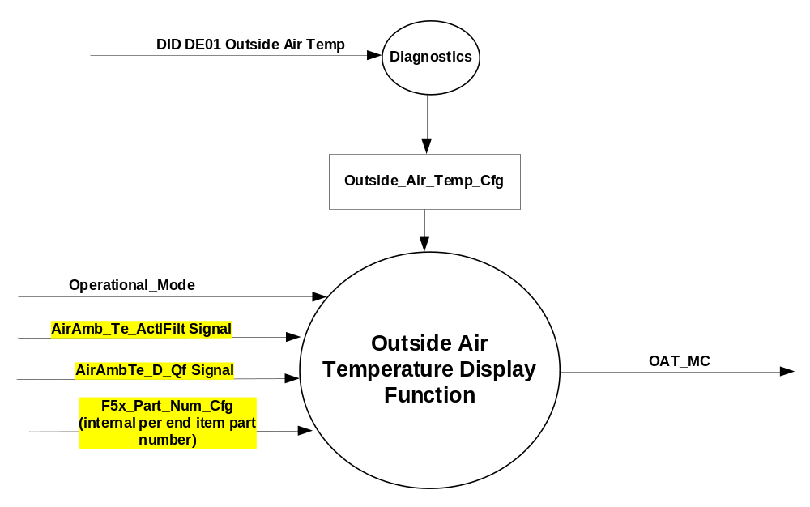

Inputs

- INTERNAL:
- Operational_Mode
- F5x_Part_Num_Cfg (Supplier internal per end item part number)

- MUX message on the CAN Bus from PCM

- AirAmb_Te_ActlFilt Signal
Signal Name | Size  (bits) | Detail | Units | Res. | Offset | State Encoded | Min. | Max.
AirAmb_Te_ActlFilt | 10 |  | Degrees C | 0.25 | -128 |  | -128 (0x0) | 127.75  (0x3FF)

Table 1.1 – AirAmbTe_D_Qf Signal
Signal Name | Size (bits) | Detail | Units | Res. | Offset | State  Encoded | Min | Max
AirAmbTe_D_Qf | 2 |  | SED | 1 | 0 |  | 0  (0x0) | 3  (0x3)
 |  | Faulty |  |  |  | (0x0)
 |  | No_Data_Exists |  |  |  | (0x1)
 |  | Not_Within_  Specifications |  |  |  | (0x2)
 |  | OK |  |  |  | (0x3)

Outputs
OAT_MC, a value sent to the message center for display

Function/Performance

Operational Modes

Mode | Differentiating Vehicle Conditions
Sleep Mode | OAT OFF
Limited Mode | OAT OFF
Normal Mode | OAT ON/OFF
Crank Mode | OAT ON/OFF

The above table references the setting of the MC flag as per this section. However, the actual MC display operational modes are displayed in the Message Center section of this SPSS.

Voltage Levels
Refer to the Cluster Features table located in the Operational Modes and Voltage Range Strategy Section in this SPSS.

Human-Machine Interface

Visual

Indicator Graphics / Display Format
For TFT display graphics, refer to approved studio PNG data. Below is example:
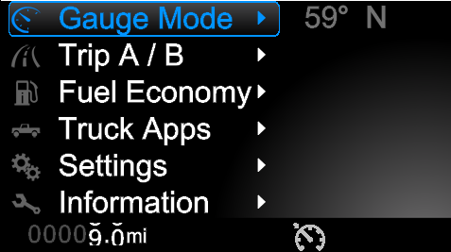

For B-display, refer to Message id IB300, IB400, IB600, and IB610 in the Text Message List – BEF Display 2x14.xls document.

Indicator Color Coordinates
None

Indicator Characteristics

Refer to Message Center X display text message list.

Audio

None.

System Accuracy

The OAT_MC shall change within 100msec of a change as indicated in the state matrix reference 1.3.5.1 Subsystem Algorithm Flowchart/ State Diagram.

Operation: Performance and Functional

Subsystem Algorithm Flowchart / State Diagram

- CAN routine

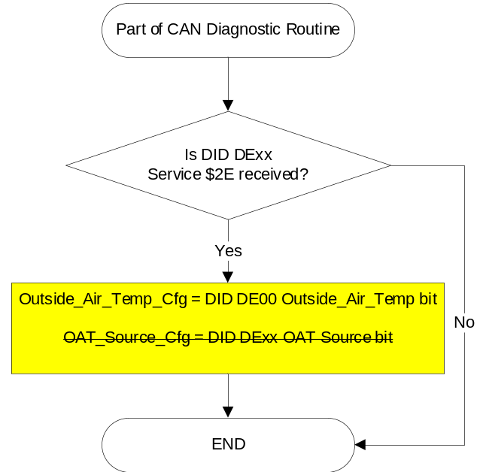

- OAT_MC routine
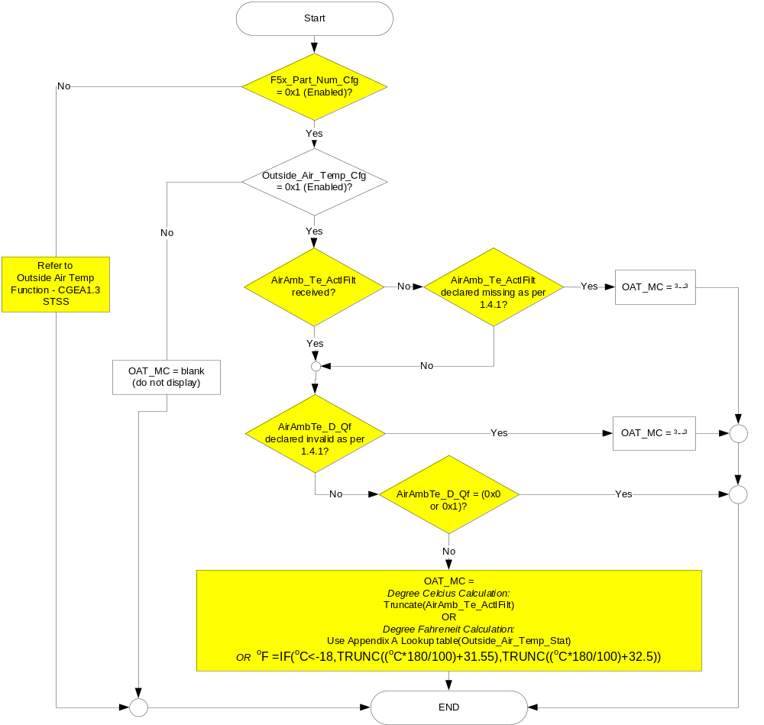

Operation Description (supports algorithm flowchart /state diagram)

- The OAT display value shall always be displayed in whole degrees only. When data is received via the CAN signal in 0.25°C increments and the value is to be displayed in °C units, the 0.25° portion shall be ignored/dropped.
- If the temperature unit is set to Fahrenheit, the OAT_MC value shall be displayed by converting the CAN signal to °F per Appendix A or from the following equation, where ºC has not yet been truncated:
ºF =IF(ºC<-18,TRUNC((ºC*180/100)+31.55),TRUNC((ºC*180/100)+32.5))
- This feature will be set to DISABLED at the instrument cluster manufacturing plant via diagnostic at Vehicle Operations using DID DE01. OAT_Cfg is set equal to the last value received in the diagnostic routine.
- The value for OAT_MC will follow the AirAmb_Te_ActlFilt signal. When the value of the associated Quality Factor (AirAmbTe_D_Qf) is 0x0 or 0x1 for greater than 5s, the display will show “- - - “ (Dashes).
- The OAT display shall consider a AirAmb_Te_ActlFilt signal value as valid data only when AirAmbTe_D_Qf has a value of OK (0x3) or Not_Within_Specifications (0x2).

Function Safety Classification (EMC)

Class B

Memory Storage

Parameter Name | Description | Value at  Battery Connect | Value at  Module Wake-up
OAT_MC | Used to control the state of the Outside Temperature Display. Can be numbers from -128 to 127, “--“, or blank (no display) | Blank | Blank
AirAmb_Te_ActlFilt signal | Filtered OAT CAN signal sent from the PCM | 0x0 | 0x0
AirAmbTe_D_Qf signal | Quality factor of outside air temp as received over CAN | No_Data_Exists (0x1) | No_Data_Exists (0x1)
Outside_Air_Temp_Cfg | Indicator of feature presence controlled via CAN at EOL at VO plant. | Use Stored Value | Use Stored Value
F5x_Part_Num_Cfg | Supplier internal NVM bit set to 0x1 (Enabled) when a cluster end item part number is for F5x. (Currently for MY20 these are LU59-10849-A/B/C/D/E/F). More end items may be added in the future, and please handle subsequent MY’s correctly for both F53 and F59. Set as required per cluster end item part number. | Use Stored Value | Use Stored Value
Operational_Mode | 4 state indicator for cluster operational mode | Limited | Limited, Normal or Crank

Prove Out

No

Reconfigurable Telltale

No

Message Center Msg

See Message Center Function

Error Handling

Missing Message Strategy

The signals will be declared missing as per the Diagnostics section of this SPSS.

DTCs states and history will be determined as per the Diagnostics section of this SPSS.

If Outside_Air_Temp_Cfg = Disabled, the cluster shall never log a missing message DTC due to this feature.

Invalid Message Strategy

The signal will be declared invalid as per the Diagnostics section of this SPSS.

DTCs states and history will be determined as per the Diagnostics section of this SPSS.

If Outside_Air_Temp_Cfg = Disabled, the cluster shall never log a missing message DTC due to this feature.

Diagnostics

Self Test
None

Engineering Test Mode
Reference section “Dealer / Engineering Test Mode (ETM)”.

Part II Performance

Supported Diagnostic Trouble Codes (DTCs)

DTC | Description
C10000 | Lost communication with ECM/PCM
C40100 | Invalid Data Received From ECM/PCM A (No sub type)
C40181 | Invalid Data Received From ECM/PCM A (invalid serial data)

DID DE01
Size (bits) | State: Description | "0" | "1" | Default | Comments/  Information
1 | Outside Air Temp | Disabled | Enabled | Disabled | When Enabled, the cluster displays OAT
1 | OAT Source | HVAC | FCIM | FCIM | 0 if vehicle has a stand-alone HVAC unit  1 if vehicle has an integrated HVAC in the FCIM
Note: Byte and bit location to be identified in Part II Specification for this cluster

Reference Specification

IS-0001 WARNINGS/INDICATORS/DISPLAYS PROVEOUT
IS-0046 INSTRUMENTATION MATERIAL RESISTANCE TO CLEANING
IS-0052 OPERATING VOLTAGES - FUNCTIONAL/PERFORMANCE
IS-0069 FUNCTIONAL IMPORTANCE CLASS
IS-0324 WINDSHIELD & OTHER REFLECTIONS
IS-0327 WARNING INDICATOR EVALUATION
IS-0329 FLICKERING OF LAMPS
IS-0379 NORTH AMERICAN WARNINGS AND INDICATORS STRATEGY

IL-0017 TELLTALE AND INTERIOR ILLUMINATION COLOR
IL-0021 CRAFTSMANSHIP - DISPLAYS
IL-0023 CLARITY/LEGIBILITY/READABILITY
IL-0025 INTERIOR ILLUMINATION INTENSITY
IL -0027 VISUAL CONTRAST
IL -0043 OPERATIONAL ENVIRONMENT FUNCTIONALITY
IL -0045 COLOR
IL -0047 TELLTALE; INDICATOR AND DISPLAY LIGHT INTENSITY
IL -0048 ILLUMINATION ACCEPTABILITY

03-0661 PLACEMENT: CONTROL AND DISPLAY LOCATIONS
03-0662 PLACEMENT: LOGICAL GROUPING FUNCTION AND USAGE
03-0664 PLACEMENT: DOWN VISION TO COMPONENTS WITH HIGH VISUAL DEMAND
03-0665 PLACEMENT: EXPECTED LOCATIONS OF CONTROLS AND DISPLAYS VDS
03-0670 INTERIOR VISIBILITY
03-0671 INTERIOR VISIBILITY: REFLECTIONS FROM COMPONENTS & SURFACES
03-0672 INTERIOR VISIBILITY: REFLECTIONS IN DISPLAYS
03-0673 INTERIOR VISIBILITY: VISUAL OBSCURATIONS
03-0674 INTERIOR VISIBILITY: ILLUMINATION CONTROLS / DISPLAYS
03-0675 INTERIOR VISIBILITY: VEILING GLARE
03-0677 INTERIOR VISIBILITY: SUNLIGHT WASHOUT
03-0681 IDENTIFICATION: CHARACTER AND SYMBOL SIZE
03-0682 IDENTIFICATION: LEGIBILITY
03-0685 IDENTIFICATION: SYMBOLS, ABBREV FOR CONTROL
03-0721 LOGIC OF OPERATION: OPERATIONAL STEREOTYPES
03-0722 LOGIC OF OPERATION: INTERPRETATION
03-0723 LOGIC OF OPERATION: USE OF SYSTEMS WITH VISUAL DISPLAYS

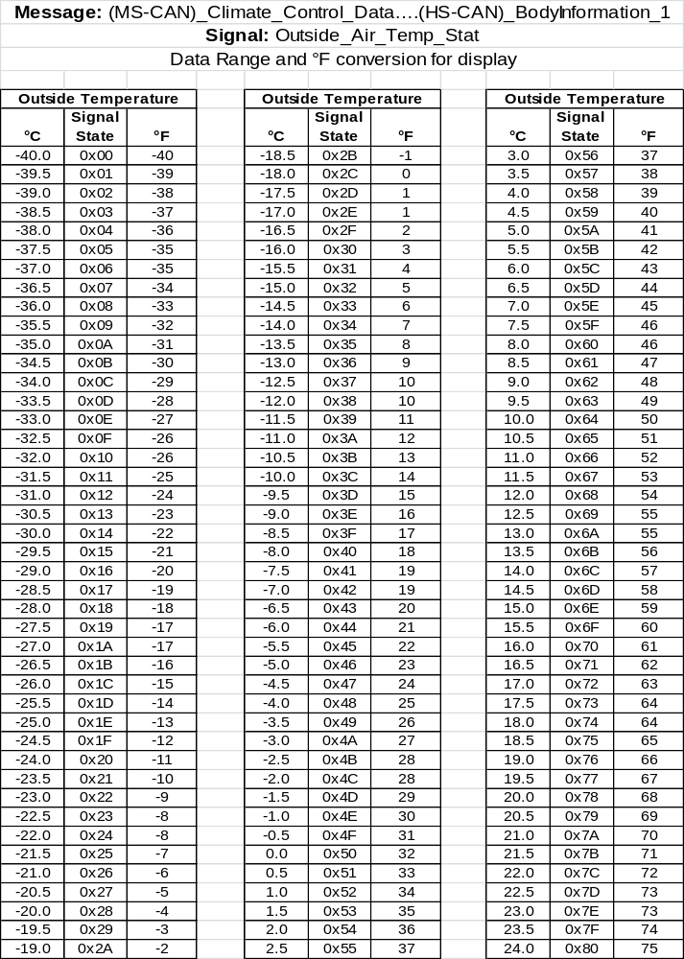

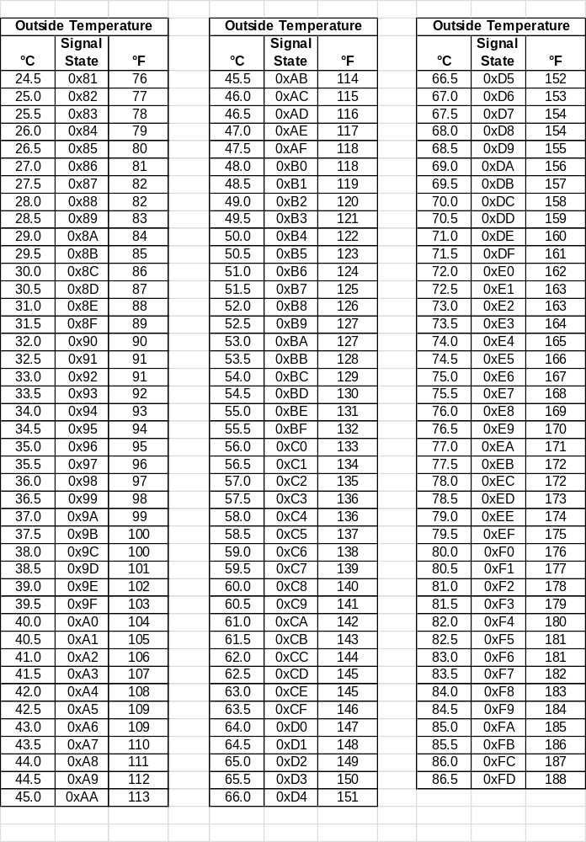

Revision History

SPSS Module Revision History
Revision Level | Name | Change Description | Date
1.0 | S. Watkins | Modified for MY20 F53/F59 programs based on CGEA 1.3 STSS version 4.0  Highlighted changes from baseline in yellow to make it easier to see the changes.  This program has no HVAC module to transmit the standard CGEA 1.3 signal for OAT. Thus, this STSS uses a filtered signal from the PCM. There are currently no plans to ever use this STSS on a different vehicle program. | 4/18/2019

